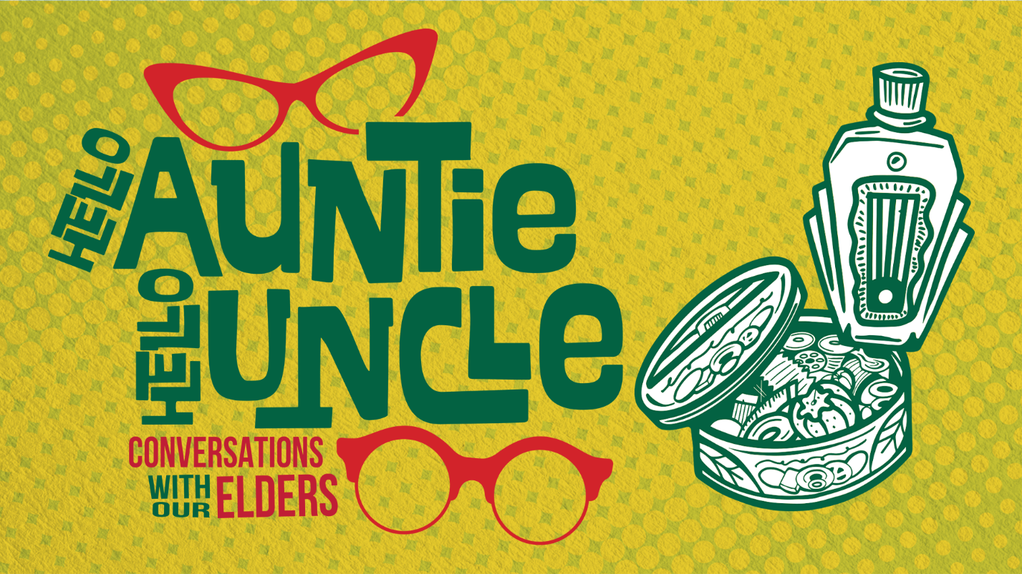
MEDIA KIT
The Wing Luke Museum media kit will help you celebrate AANHPI stories, art, and history with your community.

Social Media Accounts
Facebook: @winglukemuseum
Instagram: @winglukemuseum
YouTube: @WingLukeMuseum
LinkedIn: Wing Luke Museum of the Asian Pacific American Experience

Assets
Media Images & Graphics: Google Drive
Photograph Use: please apply photo credit using the guide below.

  - Photo 1: “CISC Seniors at APA Legislative Day in Olympia 2010. Photo Courtesy of CISC”
  - Photo 2: “ICHS making dumplings. Photo Courtesy of ICHS”
  - Photo 3: “ICHS Mid Autumn Festival 2023. Photo Courtesy of ICHS”
  - Photo 4: “Kitty with her grandmother at her grandmother’s studio apartment in Chinatown, San Francisco, CA, 1977. Photo credit: Raisa Fastman. Photo courtesy of The Outwords Archive”
  - Photo 5: “Masood and Aziza at Mount Rainier, 1983. Photo Courtesy of Maliha Masood”

Graphics Included
  - Two Square Options
  - 2000 x 1333 Option
Art by: Drag & Drop Creative

Details
Exhibit Title:
Hello Auntie, Hello Uncle: Conversations with Our Elders
Exhibit Description:
100 words:
Wing Luke Museum’s newest exhibit Hello Auntie, Hello Uncle explores the many roles Elders play in our communities, celebrates their lives and achievements, and honors the wisdom gained with time. This exhibit elaborates on who an Elder can be and what a society that values and supports an Elder might look like.
We celebrate the caregivers and community organizations that are making that world possible with first-hand community stories about living through many ages of time in this exhibit sponsored by AARP Washington.
50 words:
Wing Luke Museum’s newest exhibit Hello Auntie, Hello Uncle celebrates the lives, achievements, and wisdom of community Elders in AANHPI communities. This exhibit explores what a society that values and supports Elders might look like and celebrates the caregivers and organizations that are making that world possible with community stories.
25 words:
Wing Luke Museum’s newest exhibit Hello Auntie, Hello Uncle celebrates the lives, achievements, and wisdom of community Elders.
Run Dates:
On display from April 5, 2024 through February 23, 2025 in the New Dialogues Initiative Gallery at Wing Luke Museum
Visitation:
This exhibit is available to view with General Admission during Wing Luke Museum’s hours of operation, Wednesdays through Mondays (with the exception of observed holidays), from 10AM to 5PM at
719 S King St., Seattle, WA 98104 (Chinatown-International District).
Details about admissions and visiting Wing Luke Museum is available at www.wingluke.org/visit
Museum Street Address
This exhibit is available to view with General Admission during Wing Luke Museum’s hours of operation, Wednesdays through Mondays (with the exception of observed holidays), from 10AM to 5PM.
Exhibit Webpage
Information about the Hello Auntie, Hello Uncle exhibit is available at www.wingluke.org/helloauntiehellouncle

About Wing Luke Museum
The Wing Luke Museum’s mission is to connect everyone to the rich history, dynamic cultures and art of Asian Americans, Native Hawaiians, and Pacific Islanders through vivid storytelling and inspiring experiences to advance racial and social equity. As a Smithsonian Affiliate, National Park Service Affiliated Area, and the only pan-Asian American museum in the nation, The Wing Luke Museum is a national treasure, preserving and sharing the personal stories of the Asian American, Native Hawaiian, and Pacific Islander communities. www.wingluke.org

